**THE UNITED REPUBLIC OF TANZANIA**

**PRESIDENTS OFFICE**

**REGIONAL ADMINISTRATION AND LOCAL GOVERNMENT**

**HANANG DISTRICT COUNCIL**

**FORM FOUR EXAMINATION FEB.2024**

**013 GEOGRAPHY**

**Time: 3:00 Hours**

**INSTRUCTIONS**

1. This paper consists of sections A, B and C, with total of ten **(10)** questions.
2. Answer **all** questions in section A and B and any **two (2)** questions from section C.
3. Section A carries **fifteen (15**) marks, section B **fifty-five (55)** Marks and section C carries **thirty (30**) marks.
4. Map extract of Arusha (Sheet 53/3) is provided.
5. Programmable calculators, cellular phones and any unauthorised materials are **not** allowed in the examination room.
6. Write your examination number on every page of your answer sheet.

**SECTION A (15 Marks)**

1. For each of the items (i) – (x), choose the correct answer from among the given alternatives and write its letter in the answer sheets provided.
2. People located at different countries in different latitudes or hemispheres experience similar type of natural vegetation because of:
3. The positions which are very far
4. Similar traditions of the people living in those areas
5. The same type of climate
6. The Same onshore prevailing winds
7. Fertile soil, good cloud cover and rainfall
8. On 23rd August 2022 Tanzania as country practiced the national enumeration of people and residents so as to determine the level of development of the people, rate of employment and unemployment, birth rate and death rate and the total number of the residents. People were counted wherever they were found during of enumeration. What type of census was that?
9. Quinqunnial census
10. De jure census
11. Decennial census
12. De facto census
13. Sample survey inquiry
14. The people around Lake Nyasa were facing the problem of land shortage for agricultural activities and construction of their dwellings due to the presence of the lake, but they decided to fill sand and mud in some parts of the lake so as to have the area for performing their daily economic activities. What type of process that was done by the Nyasa people?
15. Land degradation
16. Land increase
17. Water sealing
18. Land reclamation
19. Irrigation
20. As Mr. Mbutro and his family moves from Dar es Salaam ascending in altitude towards Kilimanjaro region, he experiences changes in temperature. This means that the temperature tends to.
21. Decrease and increase at the same time
22. Decrease at the rate of 0.60C for every 100 metres
23. Increase at the rate of 0.60C for every 100 metres
24. Remain constant
25. Increase unknowingly
26. The International Date Line (IDL) is an internationally accepted demarcation on the surface of Earth. Which of the following is true about the International Date Line?
27. It runs between the South Pole and North Pole.
28. Crossing it eastwards increases the date by one date, while crossing it westwards decreases the date.
29. It serves as the boundary between one calendar day and the next
30. It passes through the Pacific Ocean, roughly following the 180o line of longitude and deviating to pass around some territories and island groups.
31. Crossing it eastwards decreases the date by one day, while crossing it westwards increases the date.
32. Mr. Kasimba is keeping a group of animals in a permanent place, he does not move from place to place with his animals looking for pasture. What is the general term for the livestock keeping category Mr. Kasimba is practicing?

A. Nomadic pastoralism B. Semi nomadic C. Transhumance D. Sedentary livestock keeping. E. Commercial animal keeping.

1. Due to the spinning effect of the earth, water and air currents do not travel in straight lines. The term used to describe this situation is;-
2. Deflation B. Reflection C. Deflection D. Direction E. Abrasion
3. The internal structure of the earth which has concentric spherical layers is subdivided into three concentric layers which are crust, mantle and core. The scientific understanding of the internal structure of the earth includes the following ways, except.
4. Digging boreholes
5. Observations of topography and bathymetry
6. Observations of rock and outcrop, sample brought to the surface from greater depths by volcanoes or volcanic activity
7. Analysis of the seismic waves that pass through the earth
8. Measurements of the gravitational and magnetic fields of the earth
9. A football match started at Nono Secondary school (760E) at 4:30Pm, what was the time at Green which mean time (GMT)?
10. 9:34pm B. 5:26am C. 11:26am D. 5:04pm E. 5.34 a.m
11. Water sources that develop in deflation hollows in deserts are called;

A: Spring B: Oases C: Mudflow D: Ribbon lakes E: Crater lakes

1. Match the items in List A with the response in List B by writing the letter of the correct response beside the item number.

|  |  |
| --- | --- |
| LIST A | LIST B |
| |  |  | | --- | --- | | i. A large depression formed at the base of waterfall  ii. Circular depressions on the riverbed  iii. The process whereby the load of the river rubs against the bed and sides of the river channel  iv. A feature formed due to river rejuvenation  v. A low-lying swampy plain which slowly becomes colonized by plants |  | | A. Knit point  B. Gorge  C. Abrasion  D. Corrosion  E. Plunge pool  F. Delta  G. Pot holes |

**SECTION B (55 Marks)**

1. Carefully study the map extract of Arusha (Sheet 53/3) provided and then answer the following questions:

(a) With evidence, describe the ways that have been used to express the scale of the given map.

(b) Suppose you were asked to walk on foot on the actual ground using the given map from grid reference 240238 to grid reference 370278. How long will you have walked when you reach at grid reference 270255 on your way back to your stating point? Use the linear scale of the given map and give your answer in km.

(c) With vivid example determine three economic activities taking place on the mapped area.

(d) Describe the nature of drainage patterns of the mapped area.

(e) What will be the bearing and direction of grid reference 300200 from grid reference 360265?

4. Study carefully the following scores awarded to 40 students in Geography test Chakalili Secondary School and answer the questions that follow:

66, 87, 79, 74, 84, 72, 81, 78, 68, 74, 80, 71, 91, 62, 77, 66, 87, 72, 80, 77, 76, 83, 75, 71, 83, 67, 94, 64, 82, 78, 77, 67, 76, 82, 78, 88, 66, 79, 64 and 71

1. Prepare a frequency distribution table with the lowest class interval of 60 – 64
2. From the distribution table prepared in (a) above calculate; -
3. Mean score
4. Median
5. Mode
6. State two advantages and two disadvantages of standard deviation

5. Form four students at Izimbwe secondary school were told to select and submit the research title to geography teacher as the preparation for coming research.

(a) Describe any four sources that can assist them to get research title

(b) Describe four problems encountered by researcher in doing research

(c) Describe the first three stages of conducting research

6. The form three students at Sahare Secondary school were tasked by their geography teacher to carryout chain survey around their sport ground so as to make boundaries of their sport ground. In accomplishing their survey, the students chose a team to lead them and that team unexpectedly found that they collected data with discrepancy due to improper arrangement of the poles.

a) What is the type of discrepancy the surveying team encountered?

b) Outline other three possible sources of the discrepancy?

c) Suggest three ways to make sure that the discrepancy will be avoided.

d) Identify three titles of the students who were involved in the form three surveying team at Sahare secondary school.

e) Identify the type land survey method conducted by the form three survey team.

7. Carefully examine the photograph below and then answer the questions that follow: 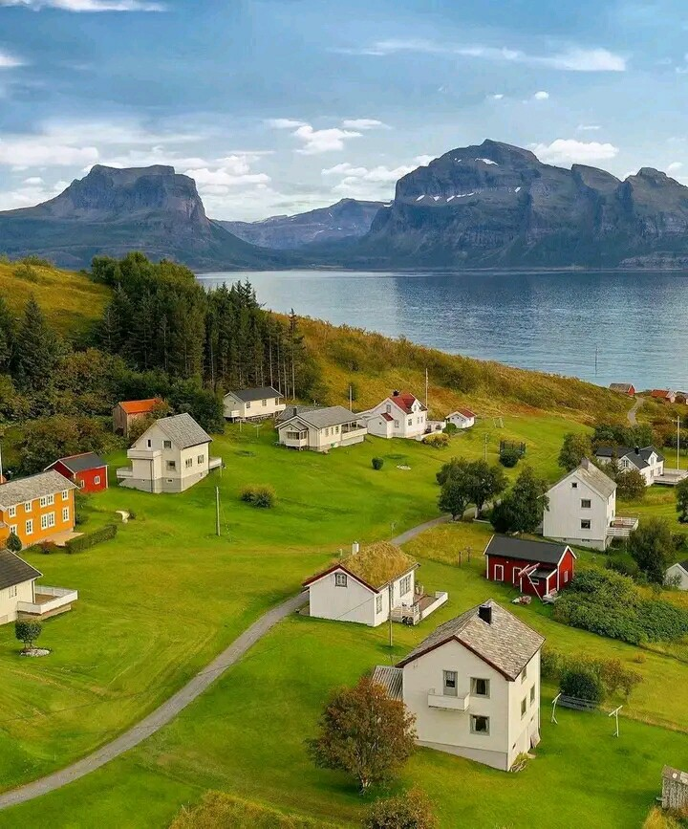

(a) Identify the type of photograph by giving two reasons.

(b) With evidences, identify any three (3) possible economic activities that might be conducted on the area.

(c) Identify the possible two (2) regions in Tanzania where this photograph might have been taken.

(d) Describe three (3) natural features found on the area.

(e) Describe the nature of relief of the area.

**SECTION C (30 Marks)**

8. Evaluate six factors that determine exploitation of minerals in Tanzania.

9. Soil is normally different from one place to another in terms of their physical, biological and chemical properties. However, this is determined by the factors and processes involved during its formation. Critically in six points elaborate how soil is beneficial to human life.

10. Explain six measures which can be taken to ensure the sustainability of forests in             Tanzania.